After looking at the data set, my first instinct was to explore the data, I was able to come up with 8 different charts to have a better understanding of the whole data set. These are listed as follows:

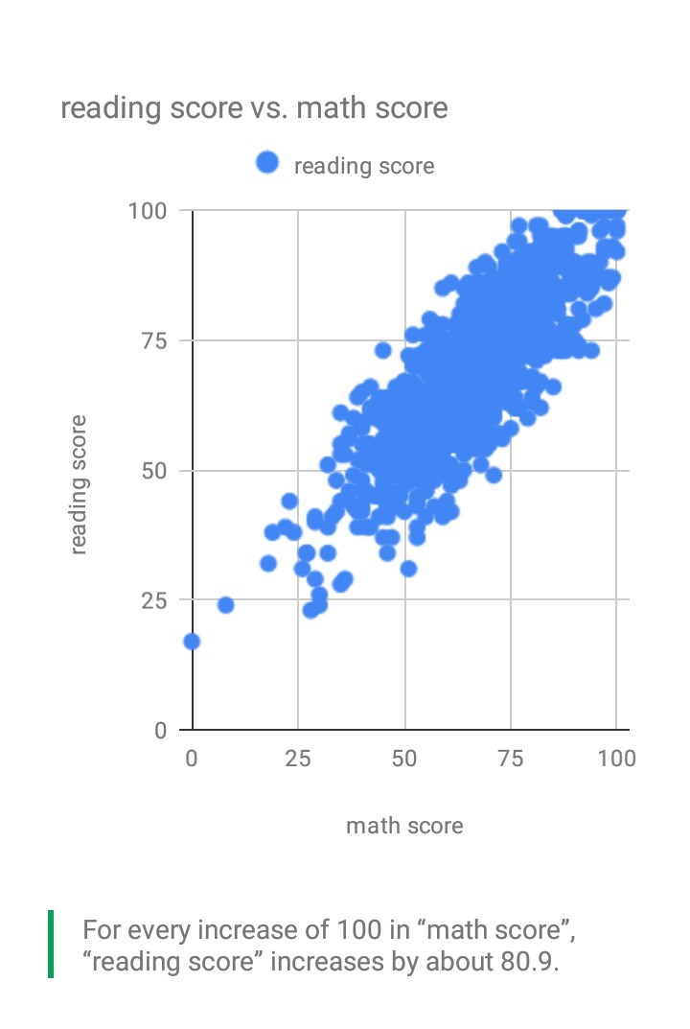

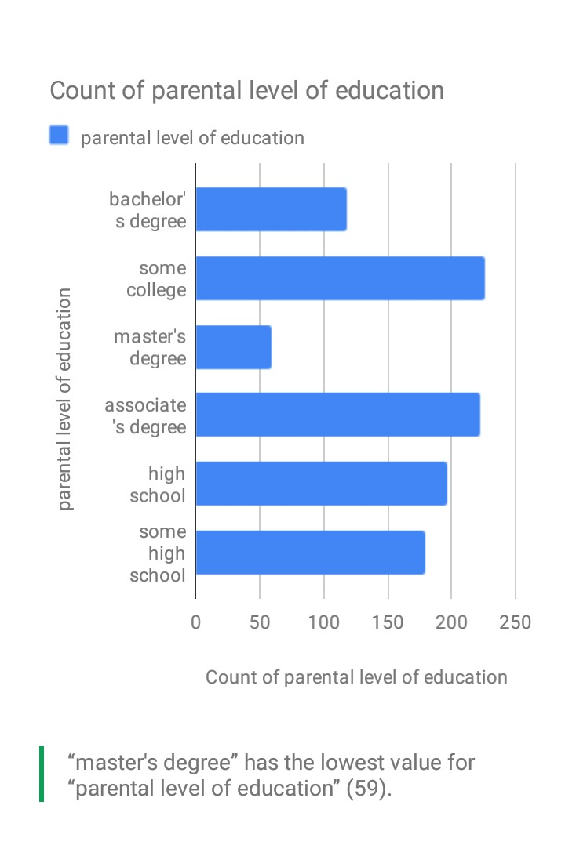

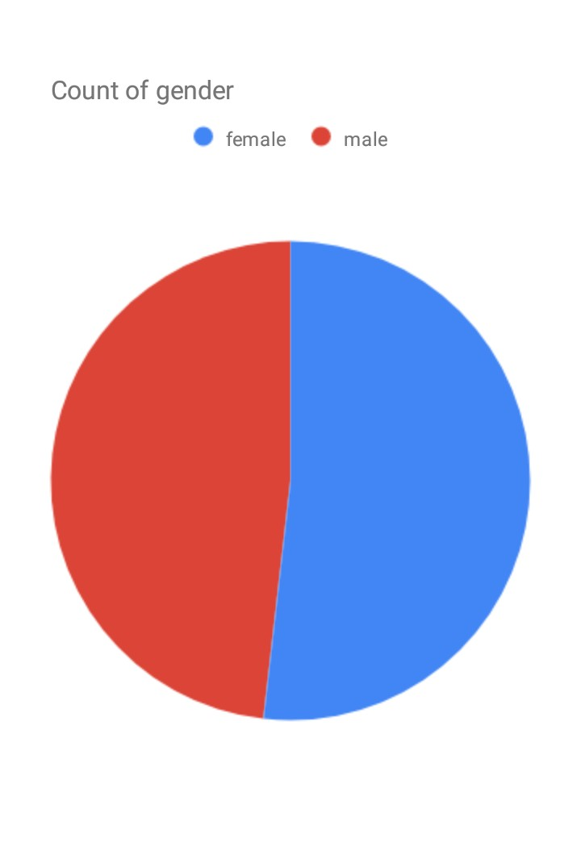

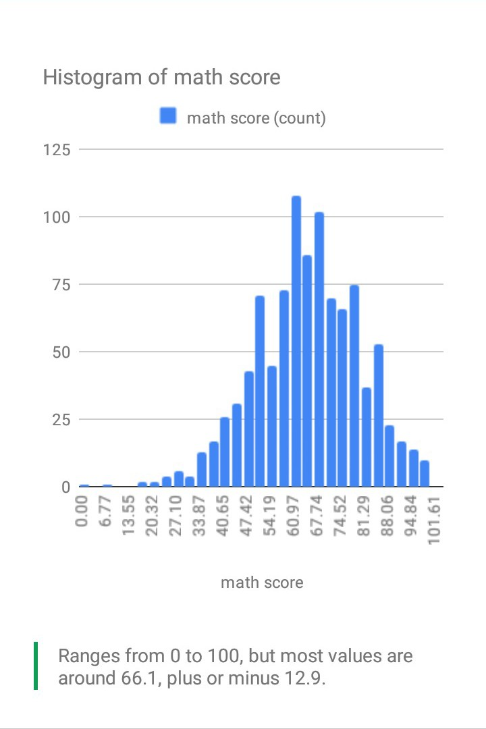

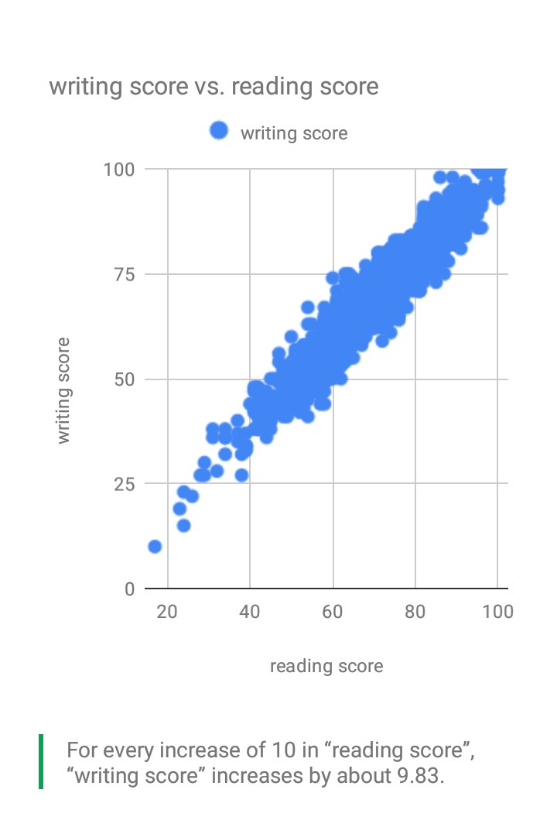

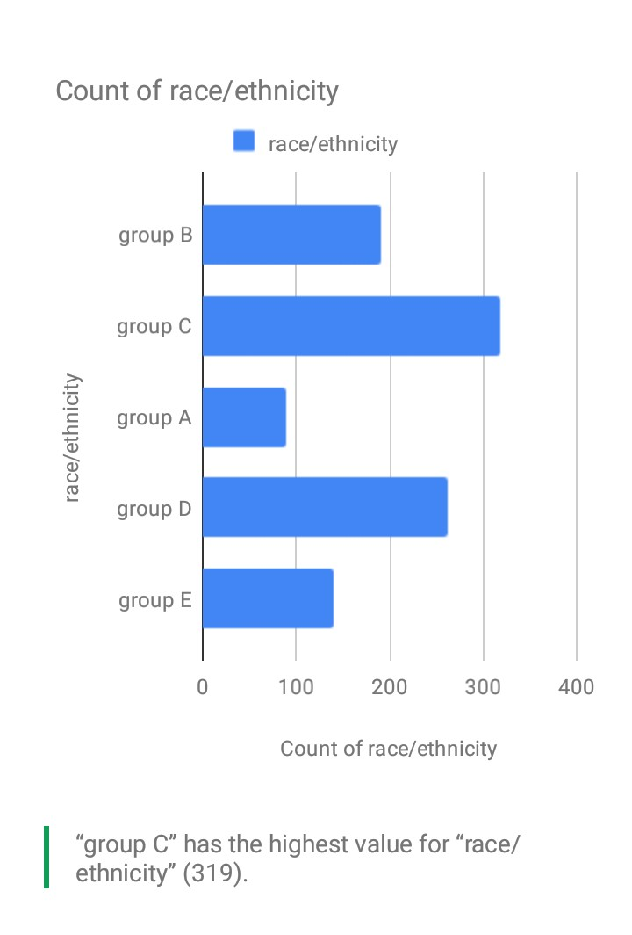

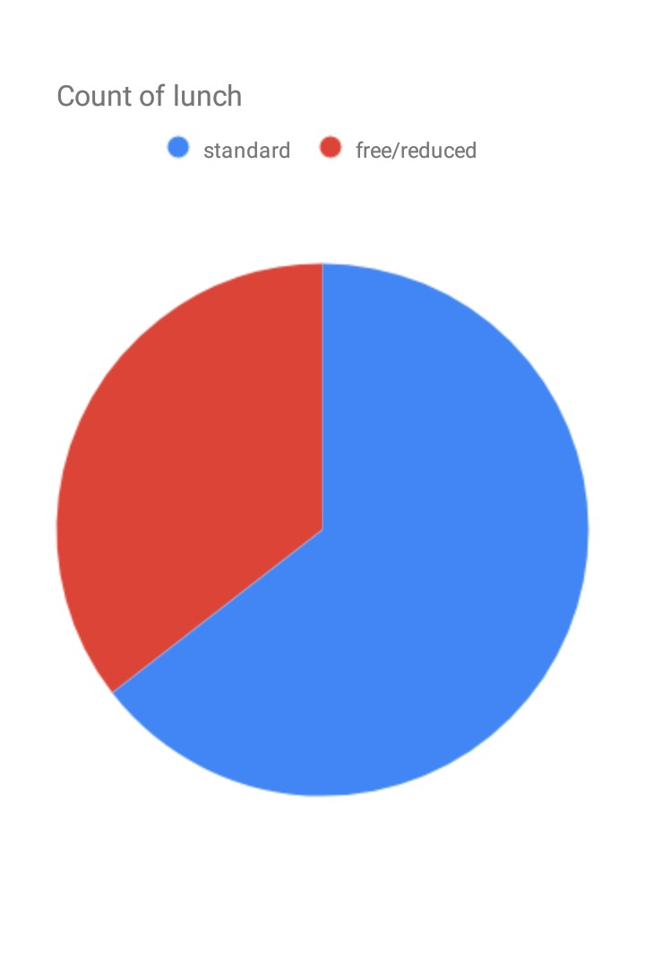

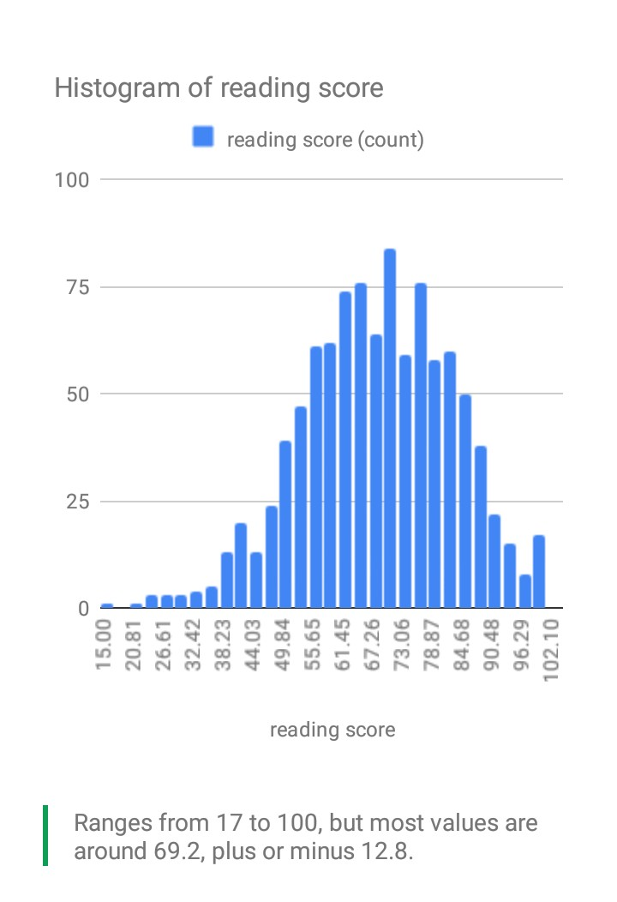My understanding of the data set suggests that the data is from a pool of respondents which their

test score was recorded and their personal characteristics were also collected.

So, it is expected that I compare their personal characteristics against the test score.

The test score is better explained in terms of the average for the 3 test categories, that's why I came up with a variable tagged average test score.

|  |  |  |
| --- | --- | --- |
| Variable (N =1000) | Frequency | Percentage (%) |
| Gender |  |  |
| Male | 482 | 48.2 |
| Female | 518 | 51.8 |
| Parental level of Education |  |  |
| Associate's degree | 1 | .1 |
| Associate's degree | 221 | 22.1 |
| bachelor's degree | 118 | 11.8 |
| high school | 196 | 19.6 |
| master's degree | 59 | 5.9 |
| some college | 226 | 22.6 |
| some high school | 179 | 17.9 |
| Lunch |  |  |
| free/reduced | 355 | 35.5 |
| standard | 645 | 64.5 |
| Test Preparation course |  |  |
| completed | 358 | 35.8 |
| none | 642 | 64.2 |

Five hundred and eighteen (51.8%) of the respondents were female while the rest 482 ( 48.2%) were males.

|  |  |  |  |  |  |
| --- | --- | --- | --- | --- | --- |
| **Descriptive Statistics** | | | | | |
|  | N | Minimum | Maximum | Mean | Std. Deviation |
| math score | 1000 | 0 | 100 | 66.09 | 15.163 |
| reading score | 1000 | 17 | 100 | 69.17 | 14.600 |
| writing score | 1000 | 10 | 100 | 68.05 | 15.196 |
| Valid N (listwise) | 1000 |  |  |  |  |

The mean maths score was 66.09 + 15,163 while the mean reading score was 69.17 + 14.6.

This indicates that the respondents had a higher score in reading compared to the other subjects.

|  |  |  |  |  |  |
| --- | --- | --- | --- | --- | --- |
| **Group Statistics** | | | | | |
|  | gender | N | Mean | Std. Deviation | Std. Error Mean |
| Average test score | male | 482 | 65.8375 | 13.69884 | .62397 |
| female | 518 | 69.5695 | 14.54181 | .63893 |

The average score of the males for the three test was 65.83 + 13.7 while the females had an average test score of 69.6 + 14.5, showing a higher score among females than males.

|  |  |  |  |  |  |  |  |  |
| --- | --- | --- | --- | --- | --- | --- | --- | --- |
|  | | F | Sig. | t | df | Sig. (2-tailed) | 95% Confidence Interval of the Difference | |
| Lower | Upper |
|  | Equal variances not assumed |  |  | -4.179 | 997.847 | .000 | -5.48452 | -1.97952 |

A T- test conducted to test for difference in the average test score between the males and the females showed that there was a statistically significant difference in the test score across gender (T= -4.179, P value <0.005).

The average test score was further analysed into two categories. Respondents with a test score between 0 and 49 were classified as failed while those with a score of 50 and above were regarded as having passed. The subsequent tables shows a proportion of the respondents that belongs to either category across different variables in the dataset.

|  |  |  |  |  |  |
| --- | --- | --- | --- | --- | --- |
| **gender * average test score category Crosstabulation** | | | | | |
|  | | | average test score category | | Total |
| failed | passed |
| gender | Female | Count | 36 | 479 | 515 |
| % within gender | 7.0% | 93.0% | 100.0% |
| Male | Count | 60 | 418 | 478 |
| % within gender | 12.6% | 87.4% | 100.0% |
| Total | | Count | 96 | 897 | 993 |

Majority (479, 93.0%) of the female respondents passed while the rest (36, 7.0%) failed.

|  |  |  |  |  |  |
| --- | --- | --- | --- | --- | --- |
| **lunch * average test score category Crosstabulation** | | | | | |
|  | | | average test score category | | Total |
| failed | passed |
| lunch | free/reduced | Count | 56 | 294 | 350 |
| % within lunch | 16.0% | 84.0% | 100.0% |
| standard | Count | 40 | 603 | 643 |
| % within lunch | 6.2% | 93.8% | 100.0% |
| Total | | Count | 96 | 897 | 993 |

|  |  |  |  |  |  |  |  |
| --- | --- | --- | --- | --- | --- | --- | --- |
| **test prep * average test score category Crosstabulation** | | | | | | | |
|  | | | average test score category | | | | Total |
| failed | | passed |  | |
| test prep | completed | Count | | 16 | 340 | | 356 |
| % within test prep | | 4.5% | 95.5% | | 100.0% |
| none | Count | | 80 | 557 | | 637 |
| % within test prep | | 12.6% | 87.4% | | 100.0% |
| Total | | Count | | 96 | 897 | | 993 |

Multivariate Analysis

|  |  |  |  |  |
| --- | --- | --- | --- | --- |
| **Model Summary** | | | | |
| Model | R | R Square | Adjusted R Square | Std. Error of the Estimate |
| 2 | .472b | .223 | .219 | 12.59910 |
| a. Predictors: (Constant), gender | | | | |
| b. Predictors: (Constant), gender, race/ethnicity, test prep, lunch, parental level of education | | | | |

|  |  |  |  |  |  |  |
| --- | --- | --- | --- | --- | --- | --- |
| **ANOVAa** | | | | | | |
| Model | | Sum of Squares | df | Mean Square | F | Sig. |
| 2 | Regression | 45283.178 | 5 | 9056.636 | 57.054 | .000c |
| Residual | 157784.895 | 994 | 158.737 |  |  |
| Total | 203068.073 | 999 |  |  |  |
| a. Dependent Variable: Average test score | | | | | | |
| b. Predictors: (Constant), gender | | | | | | |
| c. Predictors: (Constant), gender, race/ethnicity, test prep, lunch, parental level of education | | | | | | |

|  |  |  |  |  |  |  |  |  |  |  |  |  |  |  |  |
| --- | --- | --- | --- | --- | --- | --- | --- | --- | --- | --- | --- | --- | --- | --- | --- |
| **Coefficientsa** | | | | | | | | | | | | | | | |
| Model | | | Unstandardized Coefficients | | | | Standardized Coefficients | | t | | Sig. | | 95.0% Confidence Interval for B | | |
| B | | Std. Error | | Beta | | Lower Bound | | Upper Bound |
| 2 | (Constant) | 53.130 | | 2.392 | |  | | 22.209 | | .000 | | 48.436 | | 57.825 | |
| gender | 3.816 | | .798 | | .134 | | 4.782 | | .000 | | 2.250 | | 5.382 | |
| race/ethnicity | 1.884 | | .346 | | .153 | | 5.438 | | .000 | | 1.204 | | 2.563 | |
| parental level of education | 1.233 | | .226 | | .153 | | 5.462 | | .000 | | .790 | | 1.676 | |
| lunch | -8.684 | | .834 | | -.292 | | -10.413 | | .000 | | -10.320 | | -7.047 | |
| test prep | 7.737 | | .831 | | .260 | | 9.306 | | .000 | | 6.105 | | 9.368 | |
| a. Dependent Variable: Average test score | | | | | | | | | | | | | | | |

A multivariate regression model was used to analyse the relation between average test score and gender, race/ethnicity, test preparation,lunch and parental level of education. The model significantly predicted average test score though only 22.3% of the variability of the dependent variables could be explained by the model (F(5, 994) = 57.054, P value<0.001, R2 = 22.3%).

The predicted model is as follows Average test score = 53.130 + 3.816 x gender + 1.884 x race/ethinicty + 1.223 x parental level of education – 8.684 x lunch + 7.737 x test preparation.

In conclusion, I deduced the following:

1. For every increase of 100 in maths score, there was an increase of about 80.9 in the reading score.
2. Master’s degree has the lowest value for parental level of education (59).
3. There are more female (518) than male (482).
4. For every increase of 10 in reading score, there was an increase of about 9.83 in the writing score.
5. The range for the maths score was from 0 to 100, but most values were around 66.1 + 12.9.
6. The highest race/ethnicity was group C (319).
7. Free/reduced lunch had more count than standard lunch.
8. The range for the reading score was from 17 to 100, but most values were around 69.2 + 12.8.